Learner: Date:

Task 1: File types
Complete the table with the name and uses for each of the different types of file.

File type | Image | Used for
 | 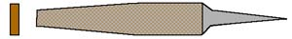
 | 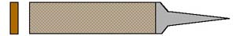
 | 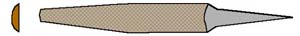

Task 2: File cuts
Describe the difference between single and double cut files.
Sketch an example of each.
____________________________________________________________________________________________________________________________________________________________________________________________________________________________________________________________________________________________________

Single cut Double cut

Task 3: File safety
Annotate the image of the file below with three checks you would make to ensure that it is safe to use.

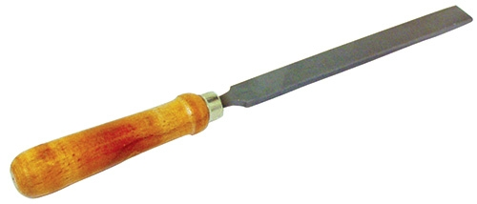

Task 4: Preparing for filing

In no more than six bullet points, describe how you would prepare material to be filed.

______________________________________________________________________________________________________________________________________________________________________________________________________________________________________________________________________________________________________________________________________________________________________________________________________________________________________________________

Task 4: Vice jaw plates/soft jaws
Explain what the item below is used for and describe the possible consequences of not using them.

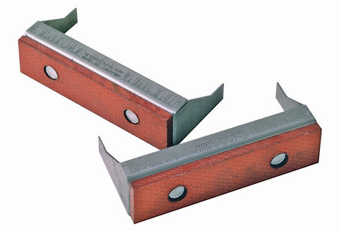

______________________________________________________________________________________________________________________________________________________________________________________________________________________________________________________________________________________________________________________________________________________________________________________________________________________________________________________

Task 5: Filing techniques
State the tools you would use and the techniques required to achieve the following:
Flat surface  (eg drill stand) | Tool(s) used:  Technique:
Square edges  (eg dice) | Tool(s) used:  Technique:
Curved surface  (eg spanner or drill stand) | Tool(s) used:  Technique:
Smooth surface finish  (eg drill stand) | Tool(s) used:  Technique:

